**NAAN MUDHALVAN PROJECT REPORT**

**MEDICAL INVENTORY MANAGEMENT**

**COLLEGE NAME:** SRI KRISHNA ADITHYA COLLEGE OF ARTS AND SCIENCE

# Code: bruag

**TEAM ID:  NM2025TMID22774**

**TEAM MEMBERS: 4**

Team Leader Name: AKALIYA S

Email:23bsds203akaliyas@skacas.ac.in

Team Member1: RAYAAN A S

Email: 23bsds246rayaanas@skacas.ac.in

Team Member2: HARINI P

Email: 23bsds219harinip@skacas.ac.in

Team Member3: SHAHAR BANU M

Email: 23bsds255shaharbanum@skacas.ac.in

**1.INTRODUCTION**

# 1.1 PROJECT OVERVIEW

This project is a comprehensive Salesforce application to streamline and manage various operational aspects of medical inventory. The system aims to efficiently maintain supplier details, manage purchase orders, track product details and transactions, and monitor the expiry dates of products. Maintain detailed records of suppliers, including contact information. Catalog product information, including descriptions, stock levels. Monitor and track product expiry dates to avoid using expired items. Comprehensive reports to track supplier performance, and purchase orders.

# 1.2 PURPOSE

The purpose of the **Medical Inventory Management System** project is to design and implement a real-time Salesforce application that streamlines the end-to-end management of medical inventory by maintaining accurate supplier records, tracking purchase orders, monitoring product stock levels and expiry dates, and enabling efficient reporting and analysis.

**DEVELOPMENT PHASE**

# Creating a developer account

By using this url: <https://developer.salesforce.com/signup>

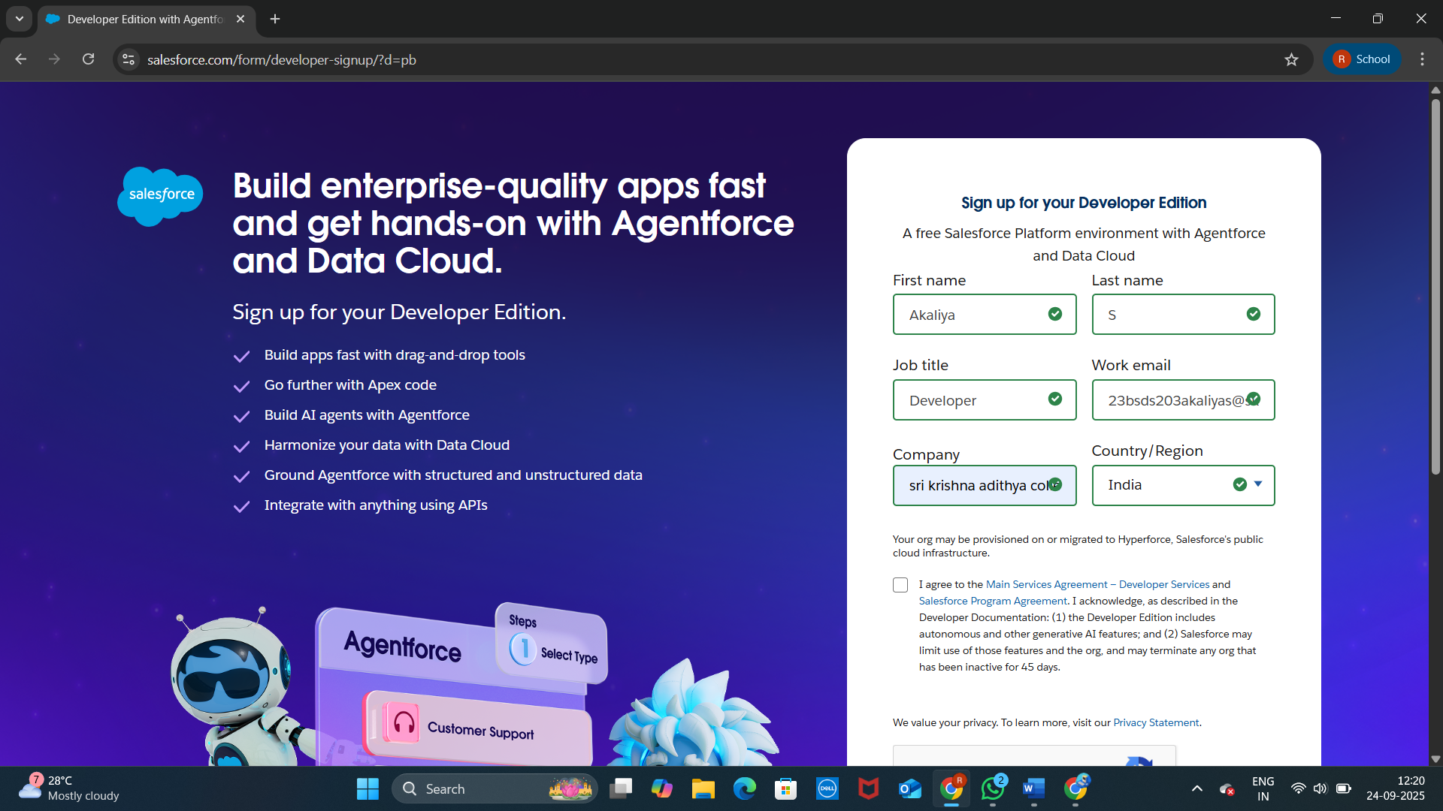

# Created Objects

Products

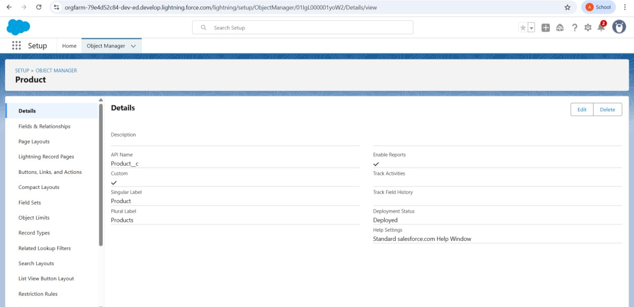

Purchase Order

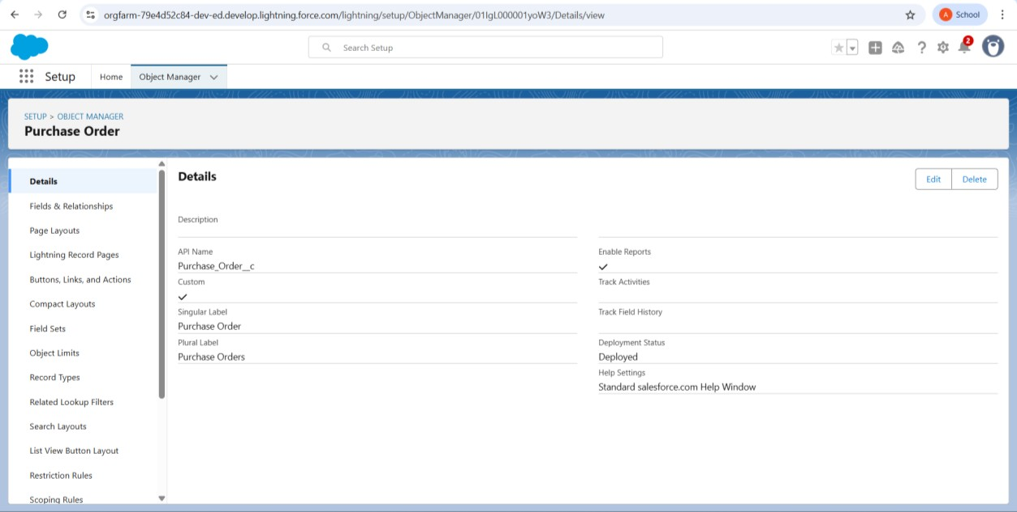

Order Item

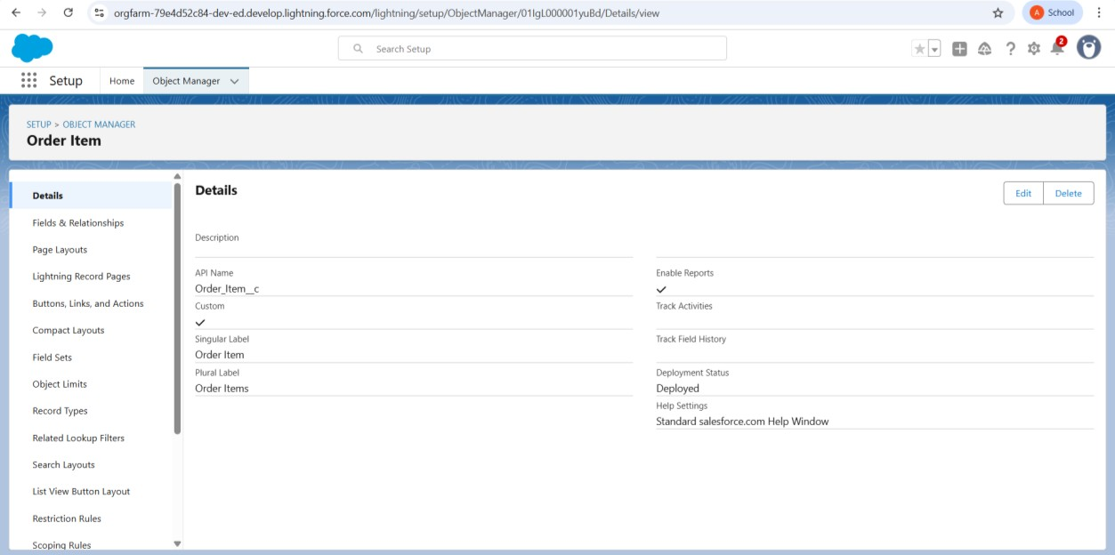

Inventory Transaction

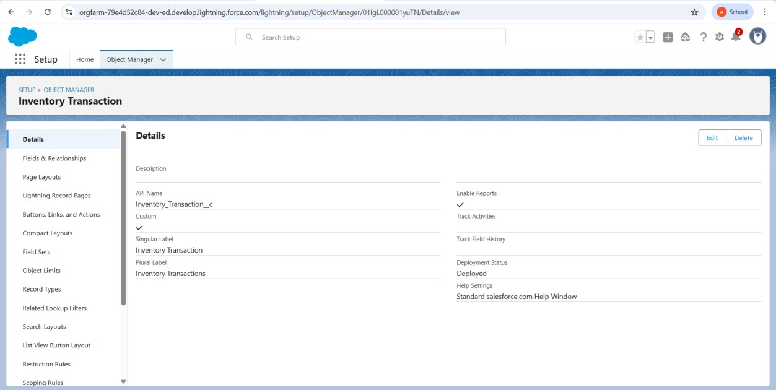

Supplier

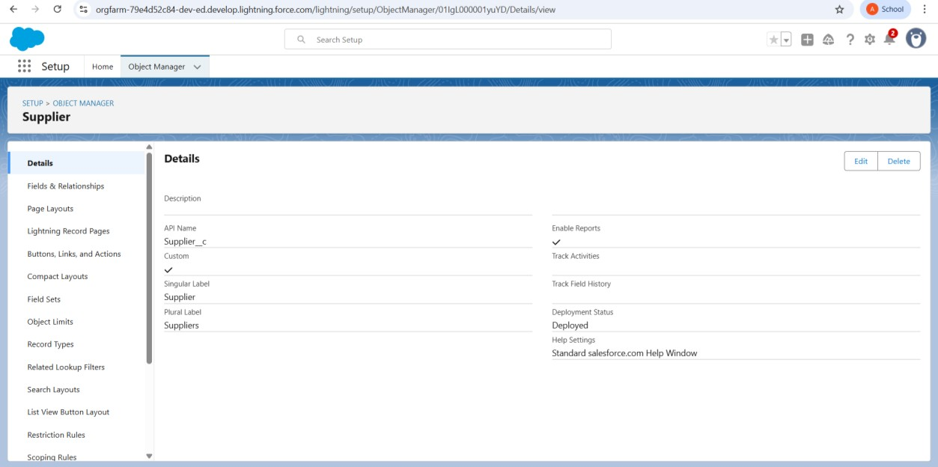

# Custom Tabs

Product, Purchase Order, Order Item, Inventory Transaction, Supplier.

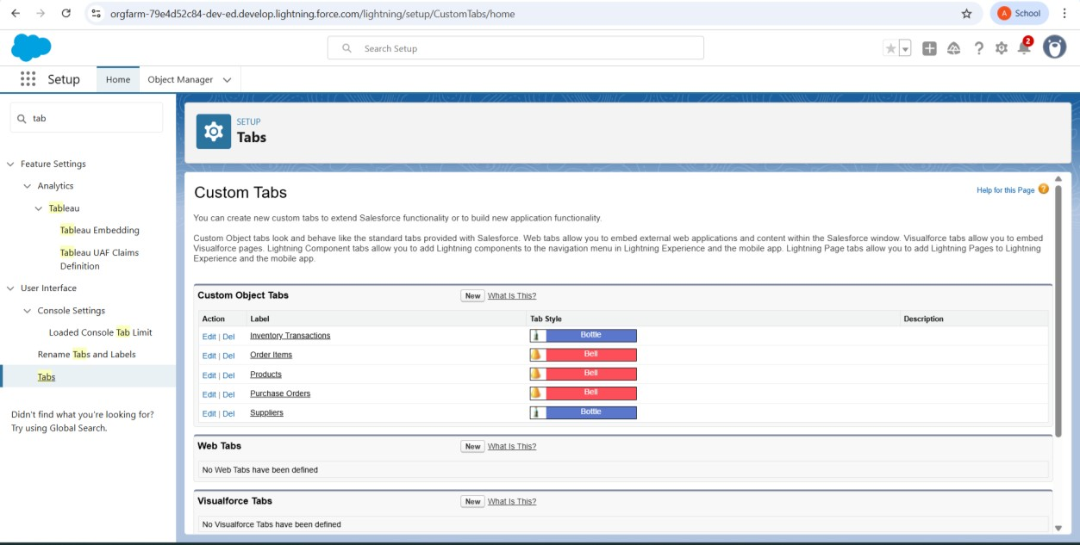

# Lightning App for Medical Inventory Management

Name: Medical Inventory Management.

Add Navigation Items: Product, Supplier, Purchase Order, Order Item, Inventory Transaction, Reports, Dashboards.

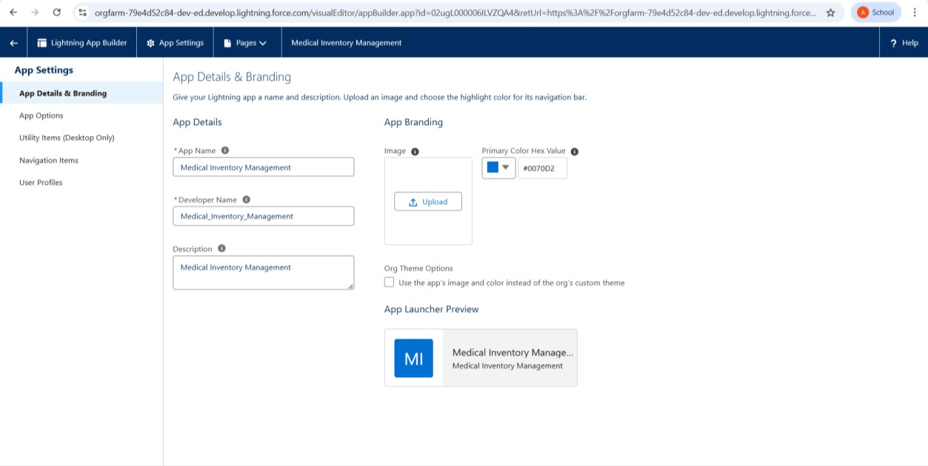

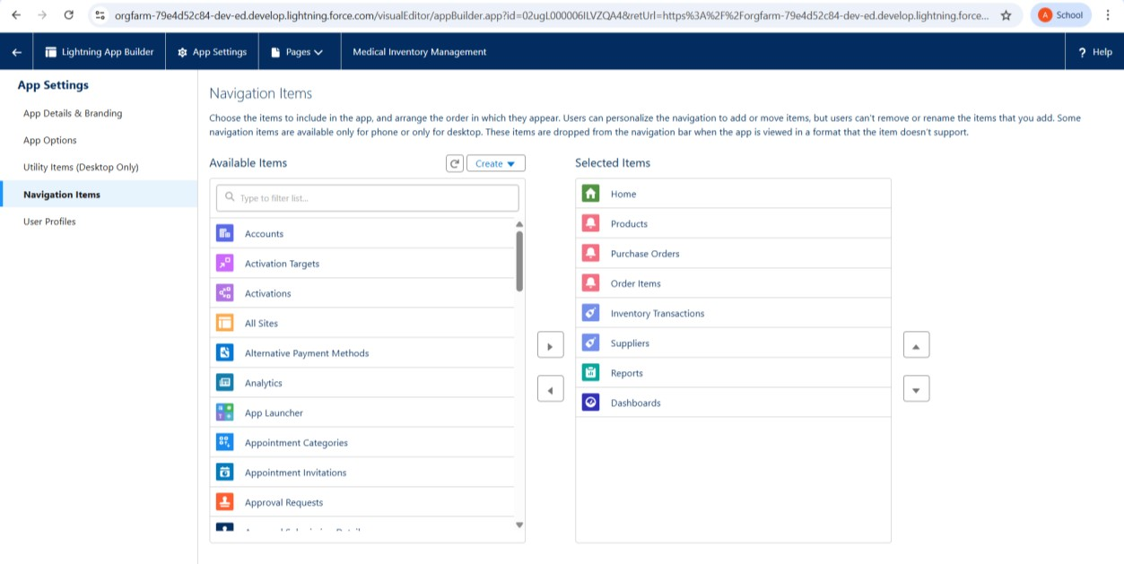

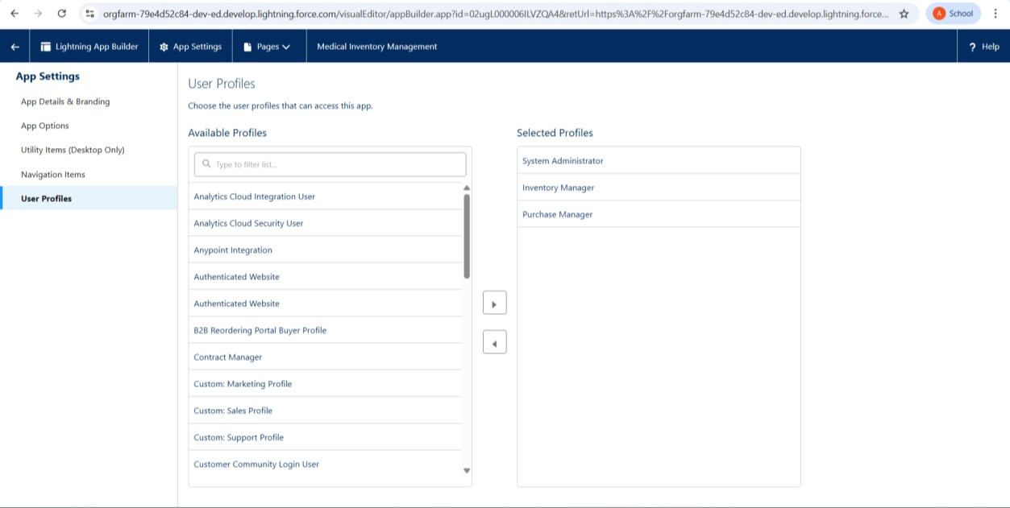

# Fields and relationships

Product

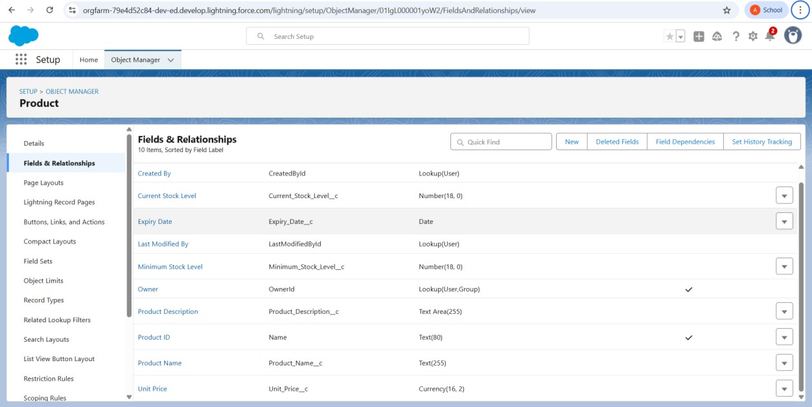

Purchase Order

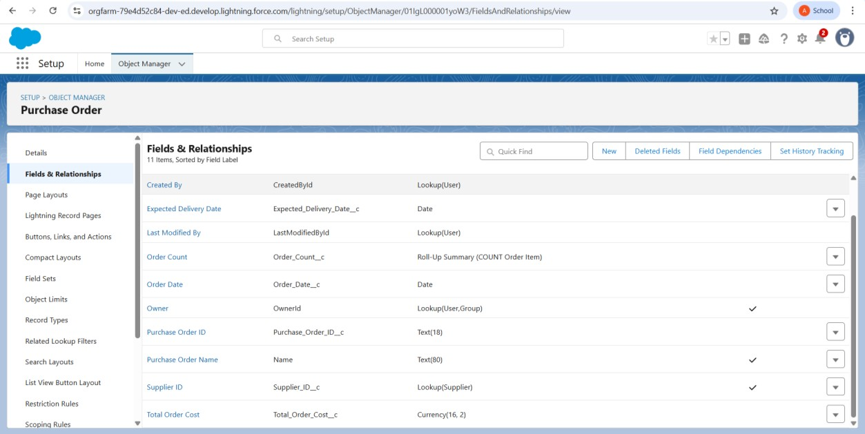

Order Item

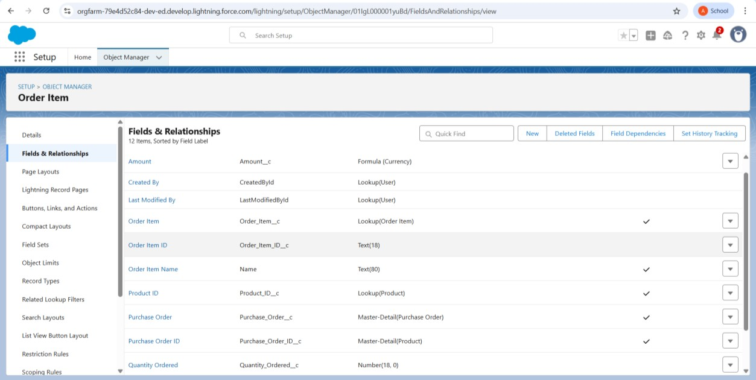

Inventory Transaction

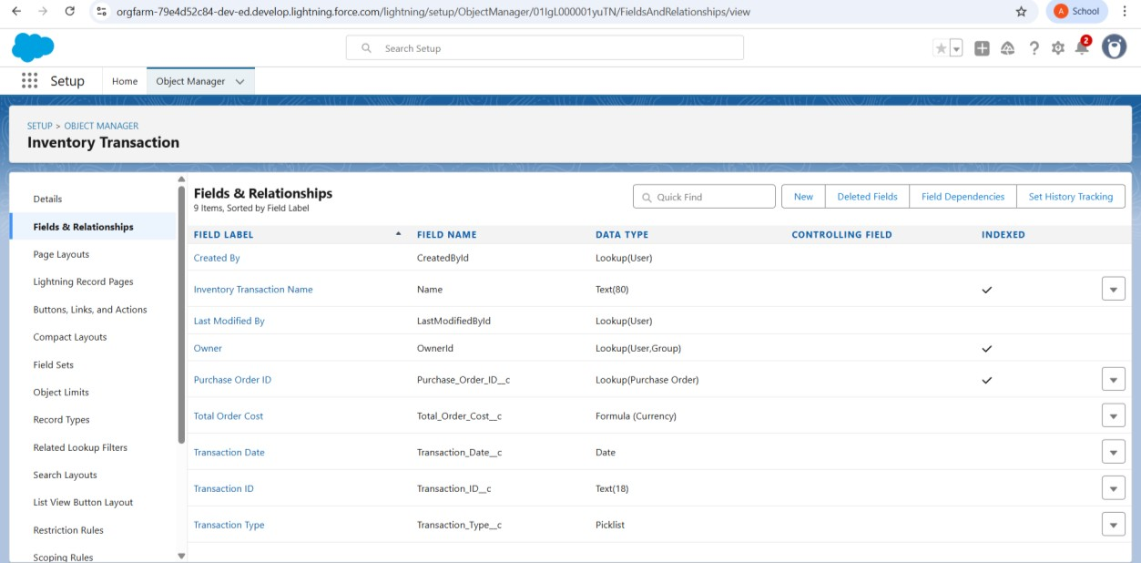

Supplier

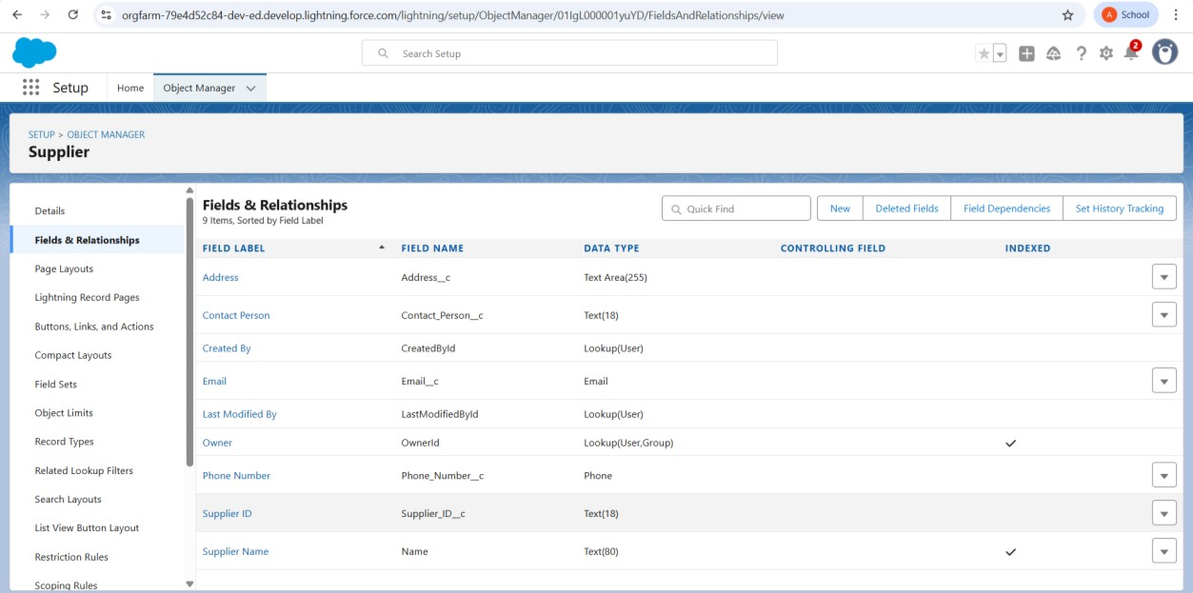

# Editing of Page Layouts

Product layout

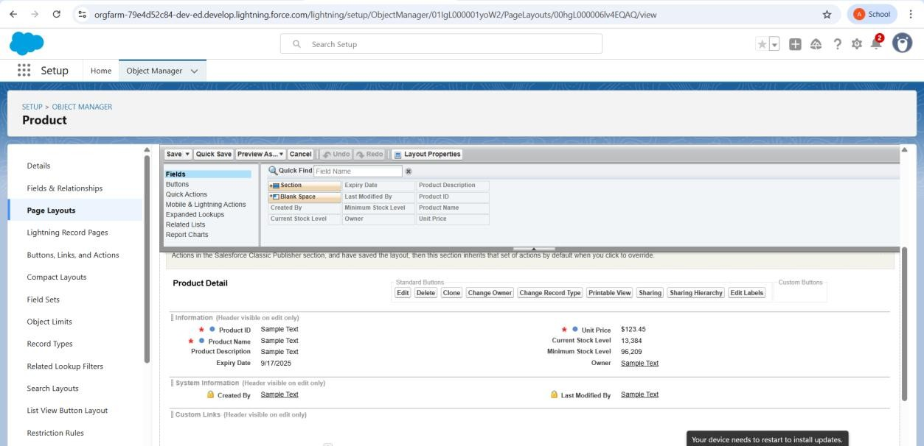

Purchase Order Layout

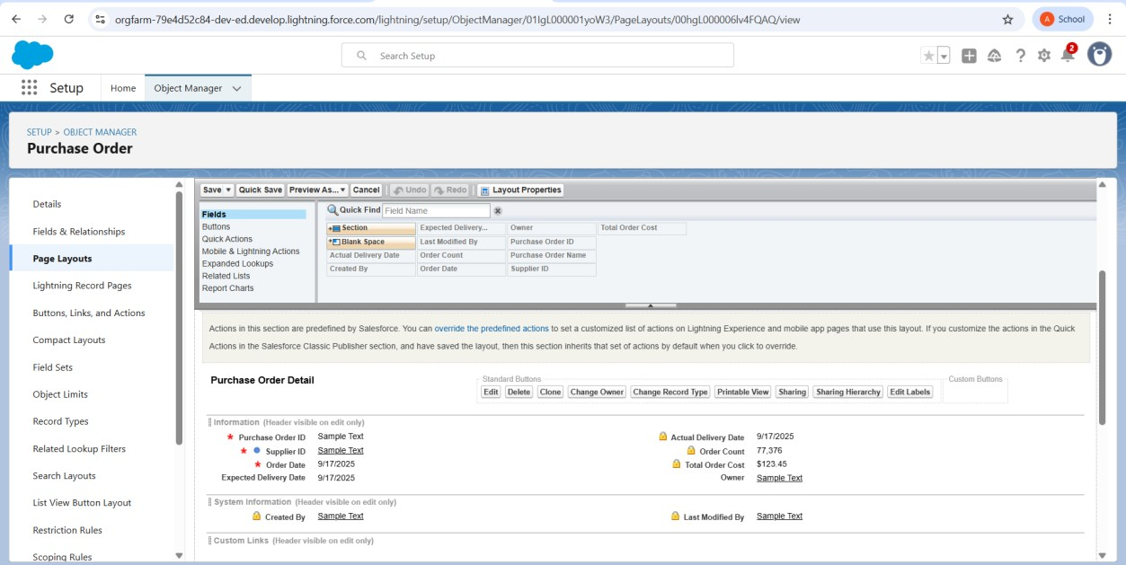

Order Item Layout

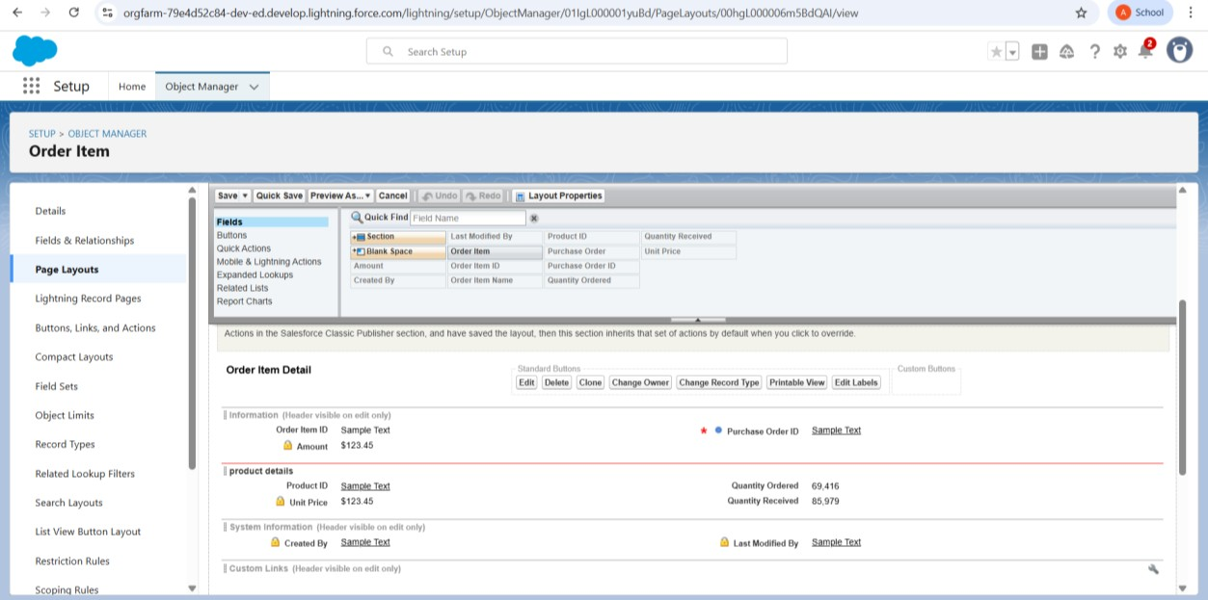

Inventory Transaction Layout

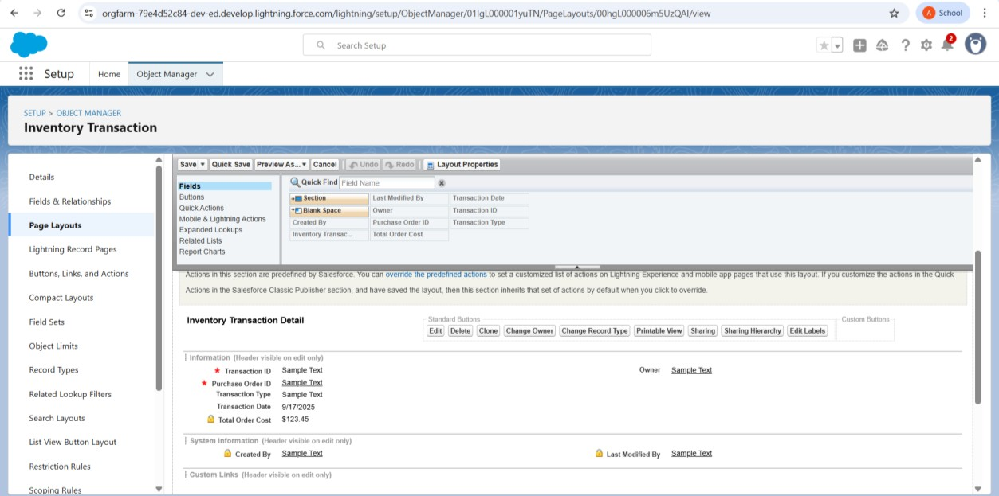

Supplier Layout

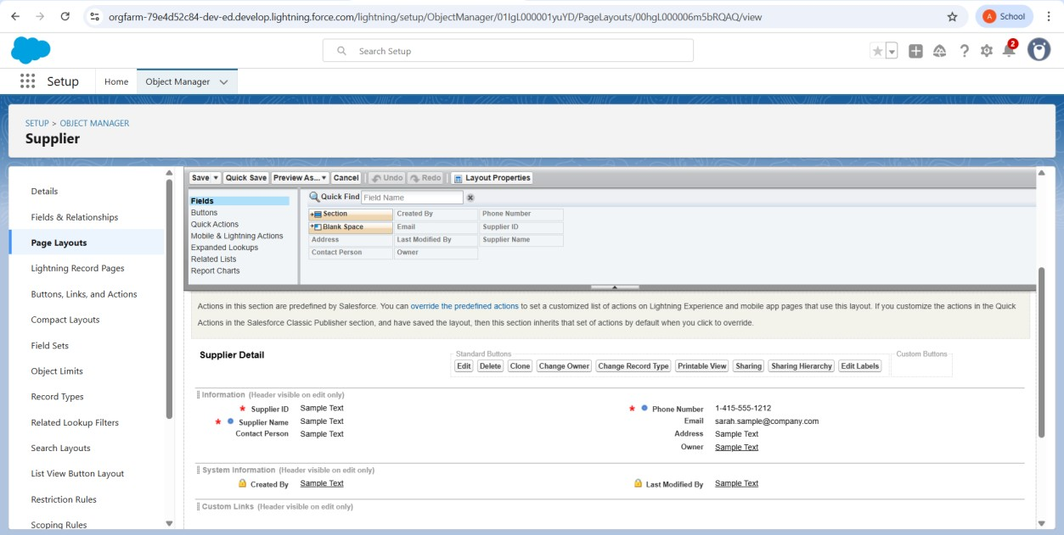

# Compact Layouts

Product Compact Layout

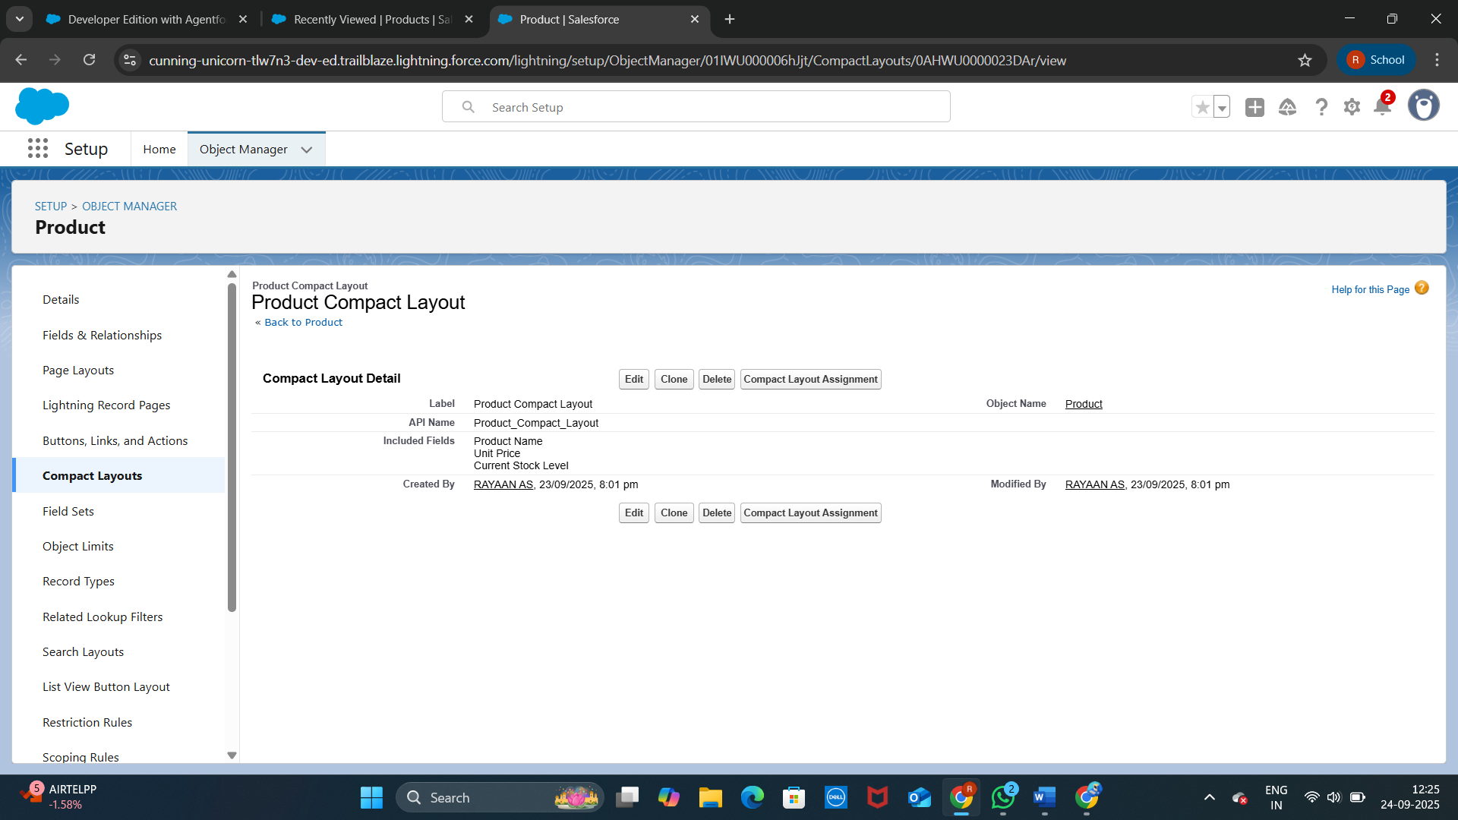

Product Order Compact Layout

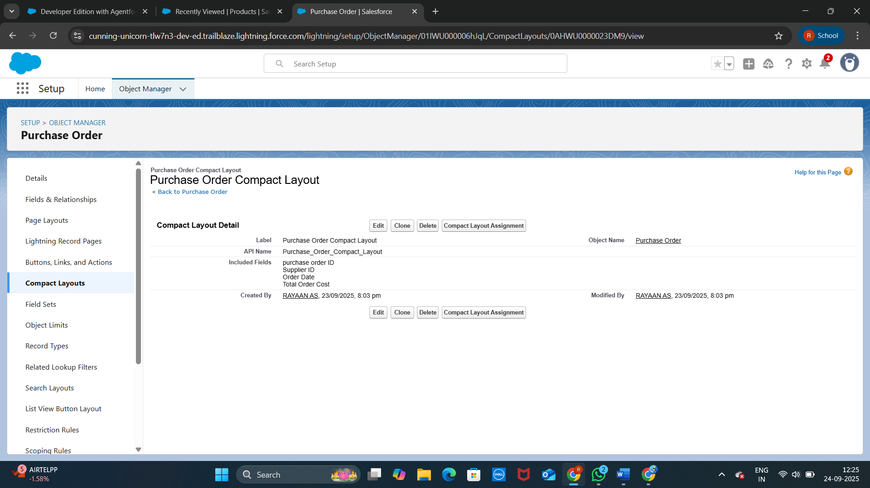

# Validation Rules

Purchase Order Delivery Date Validation

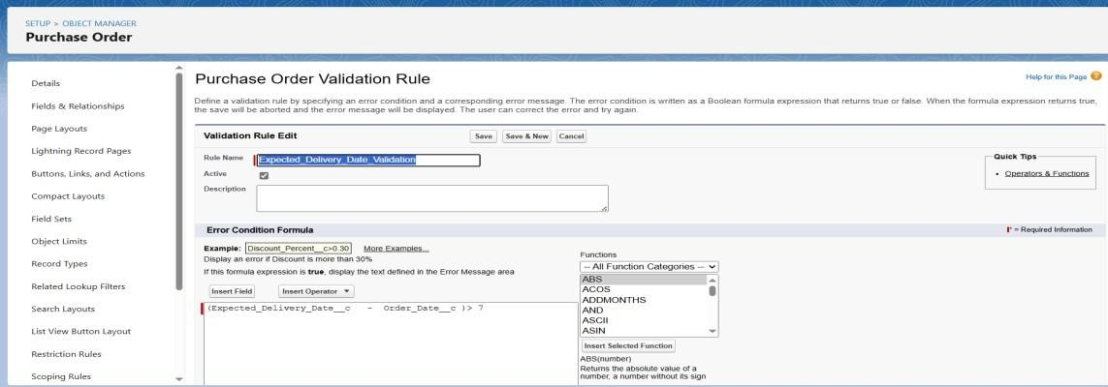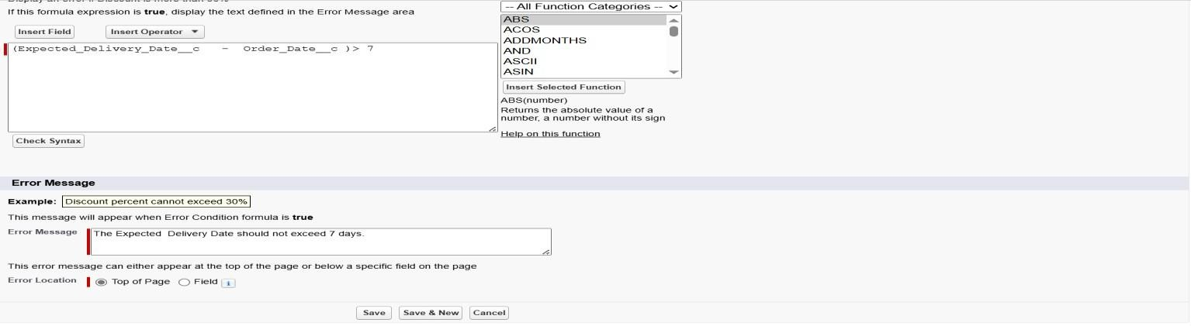

Profiles

Inventory Manager → Access to Product & Inventory.

Purchase Manager → Access to Suppliers & Orders.

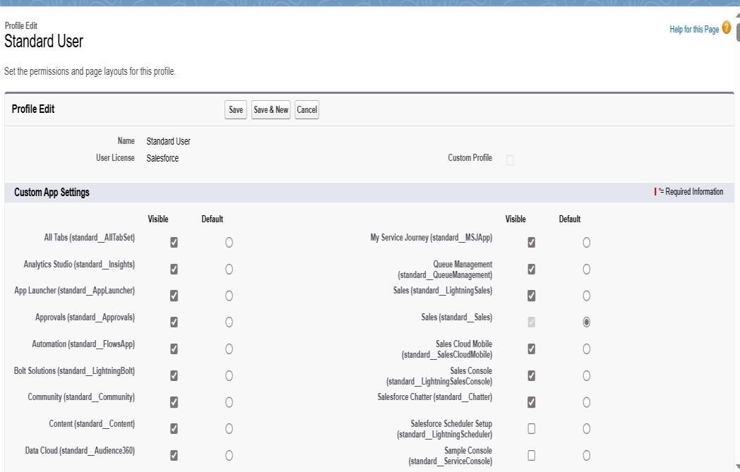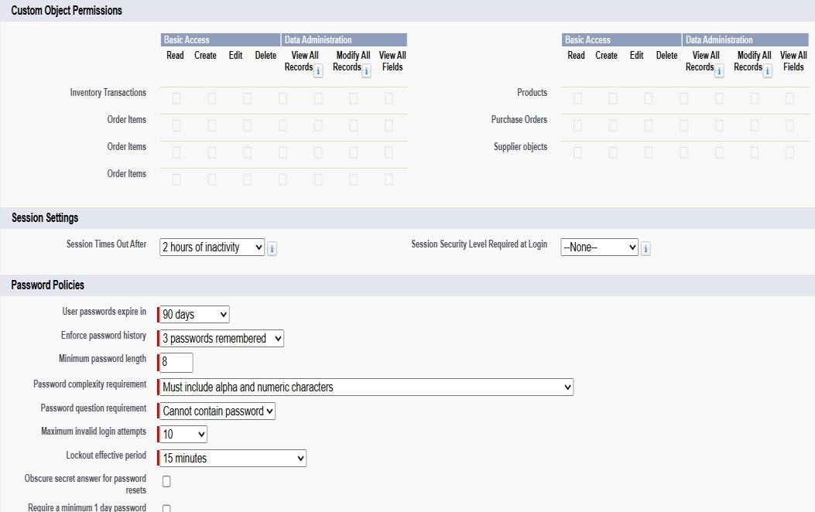

# Roles And Users

Purchasing and Inventory Manager Roles

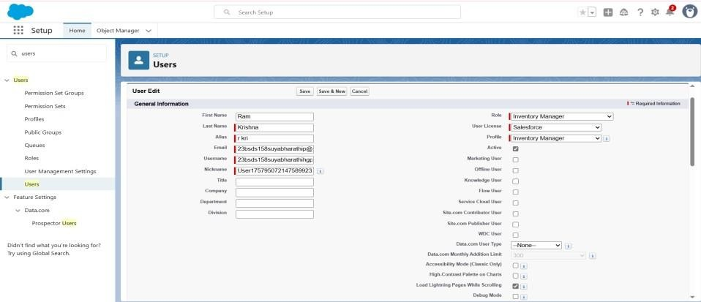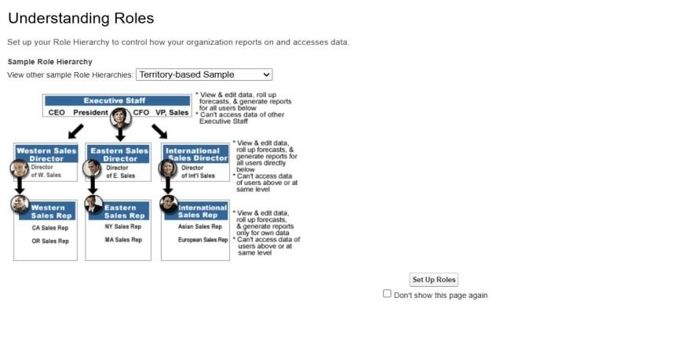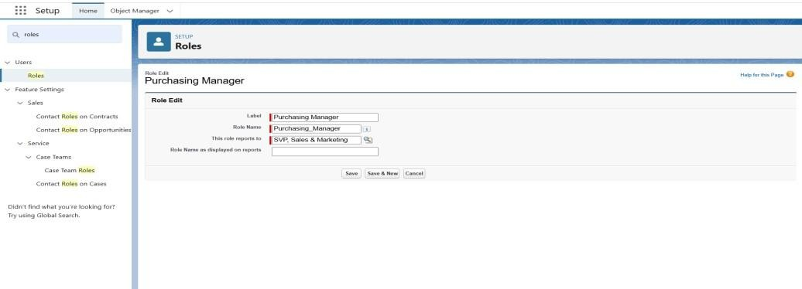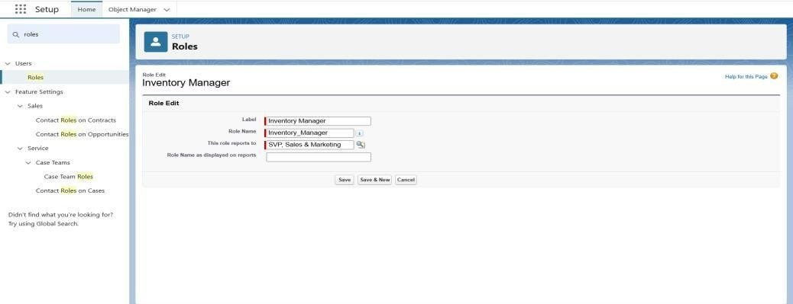

*John* → Role: Purchase Manager, Profile: Purchase Manager.

*Ram* → Role: Inventory Manager, Profile: Inventory Manager.

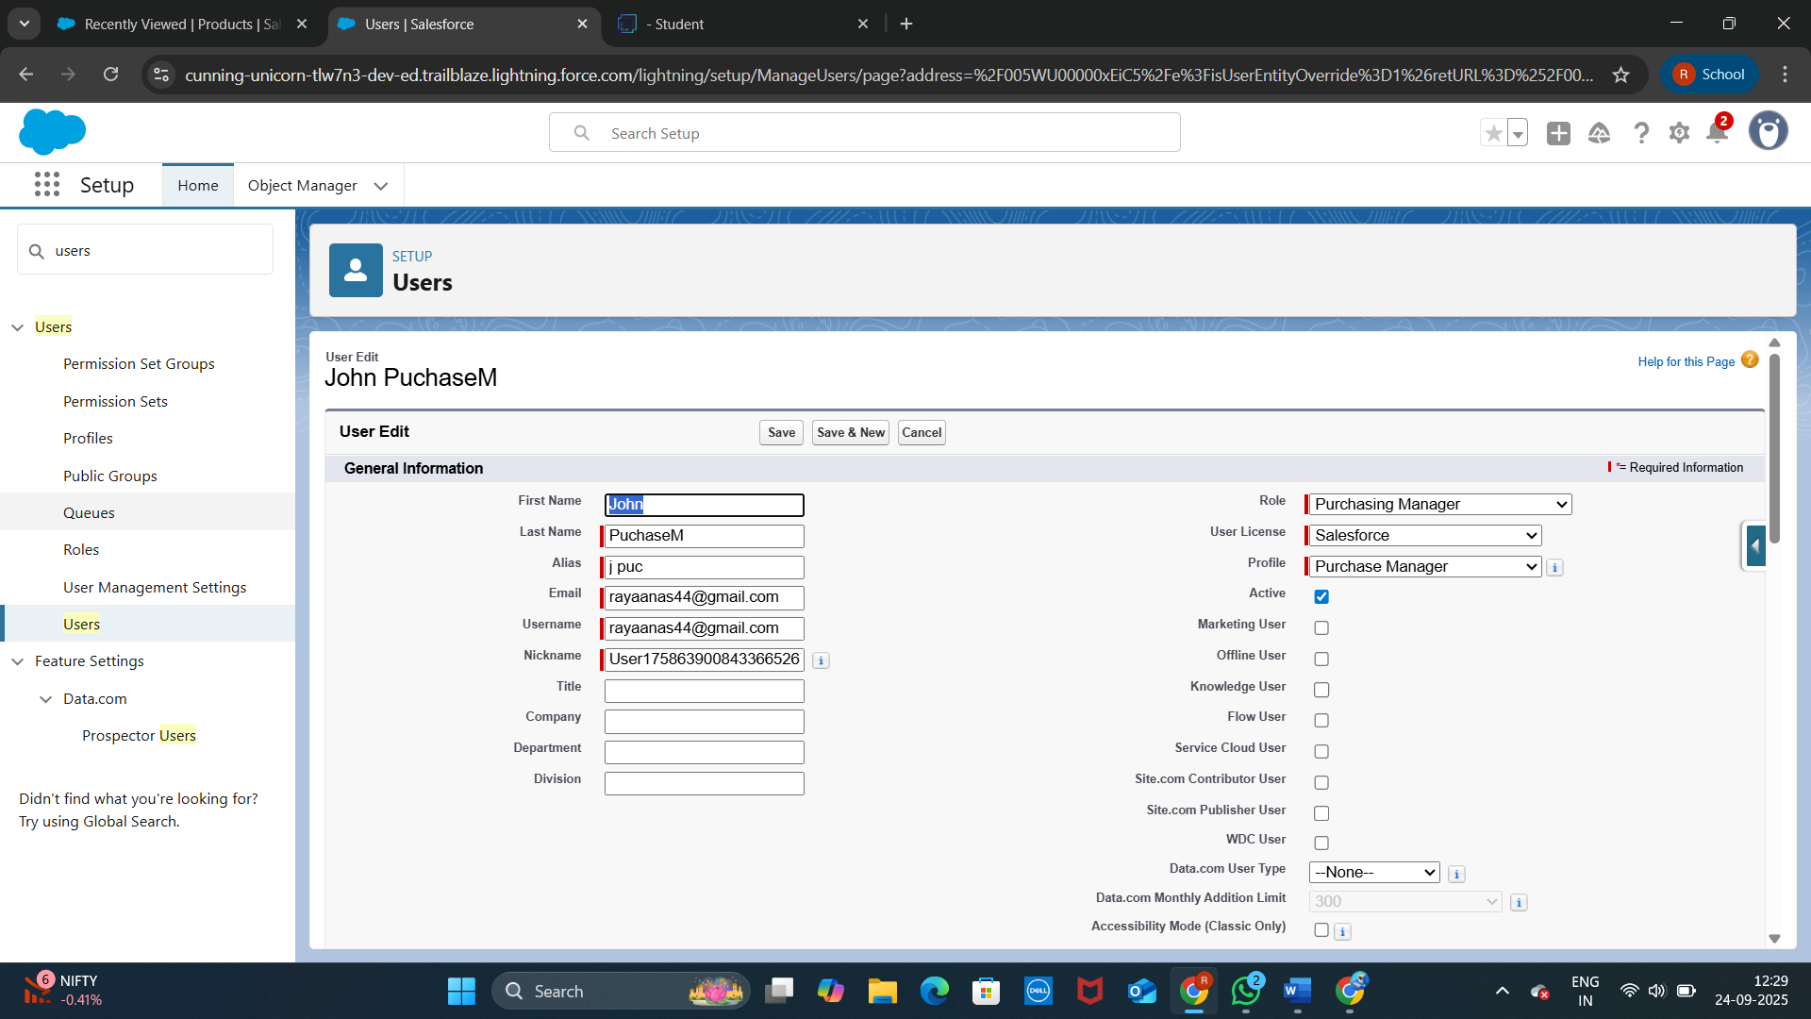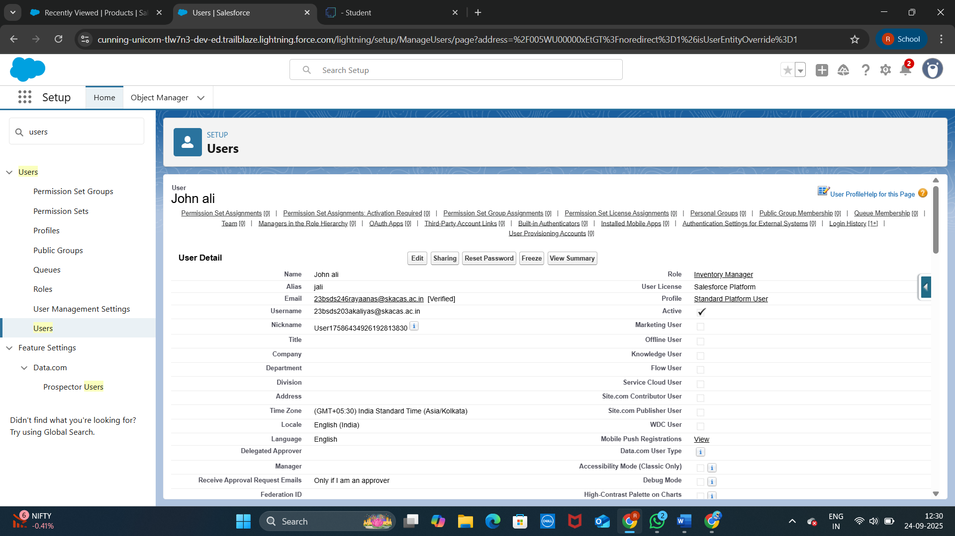

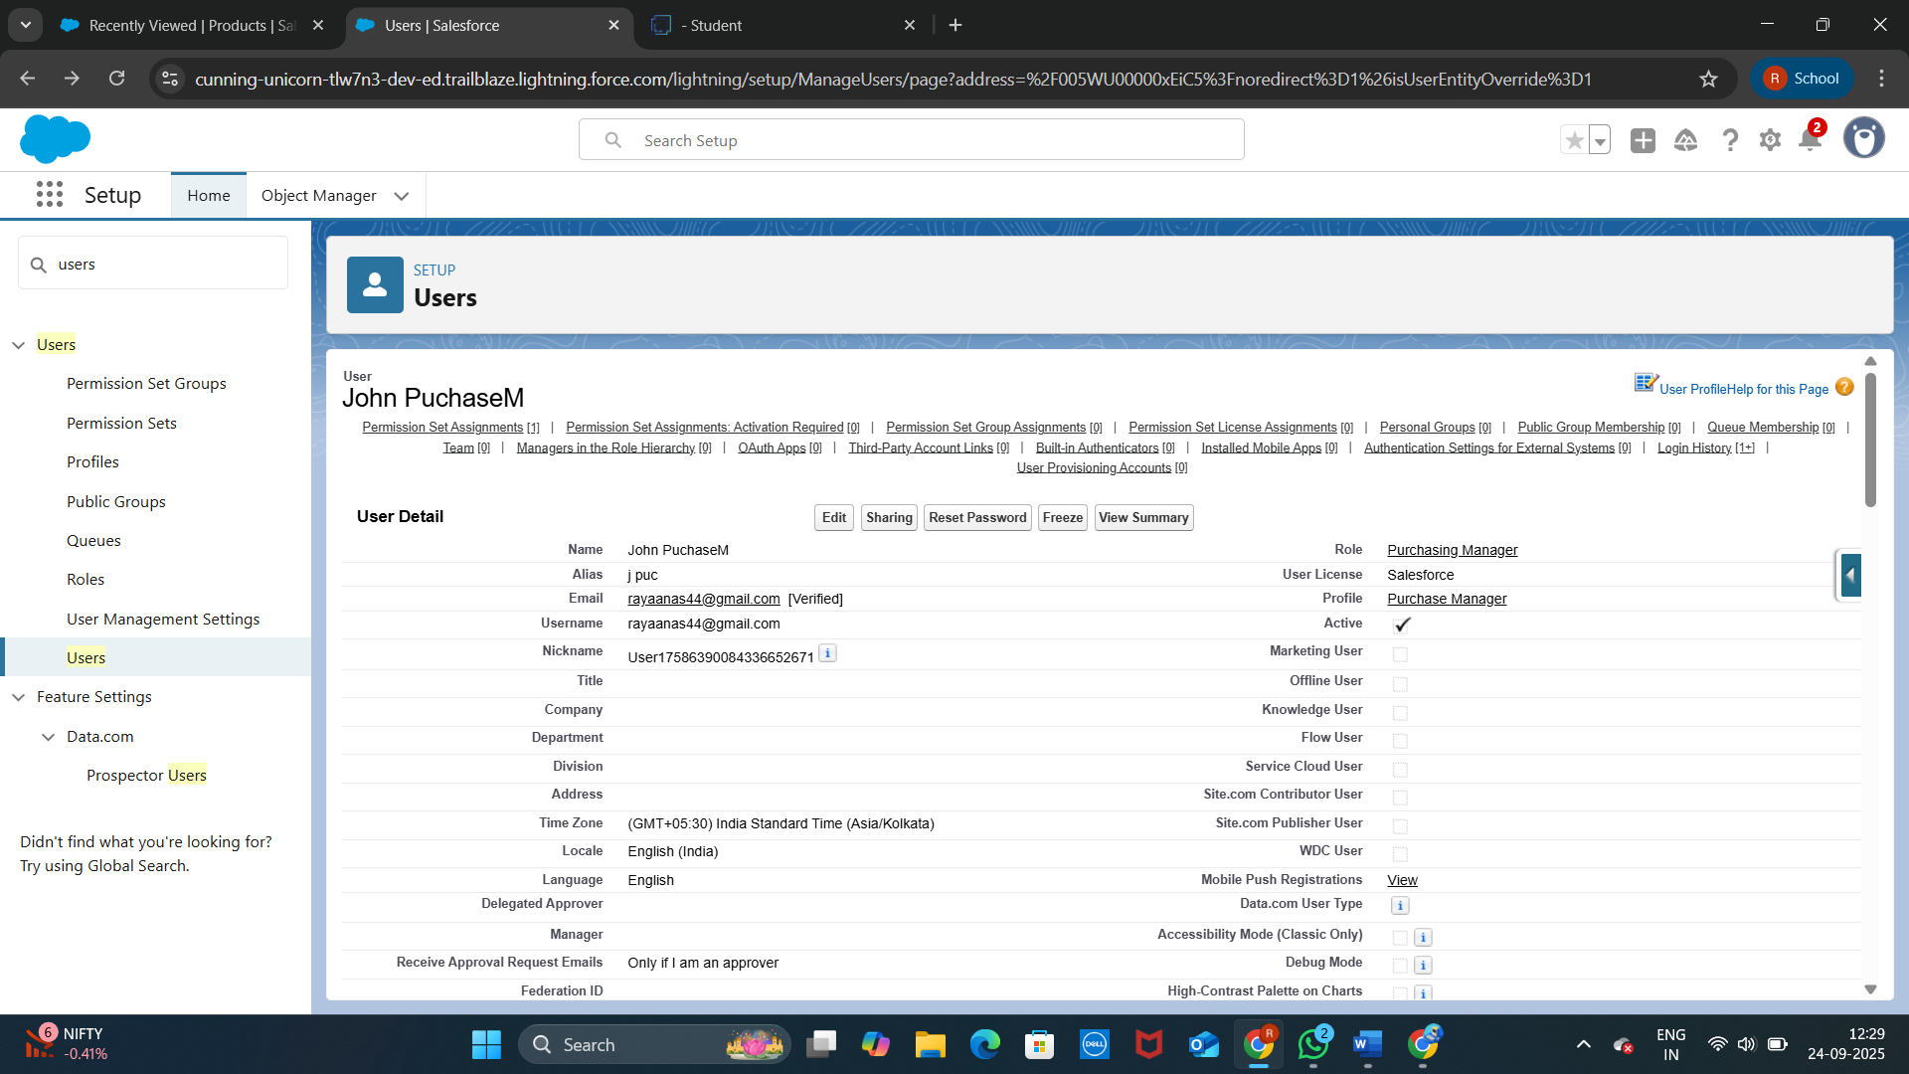

# Permission Sets

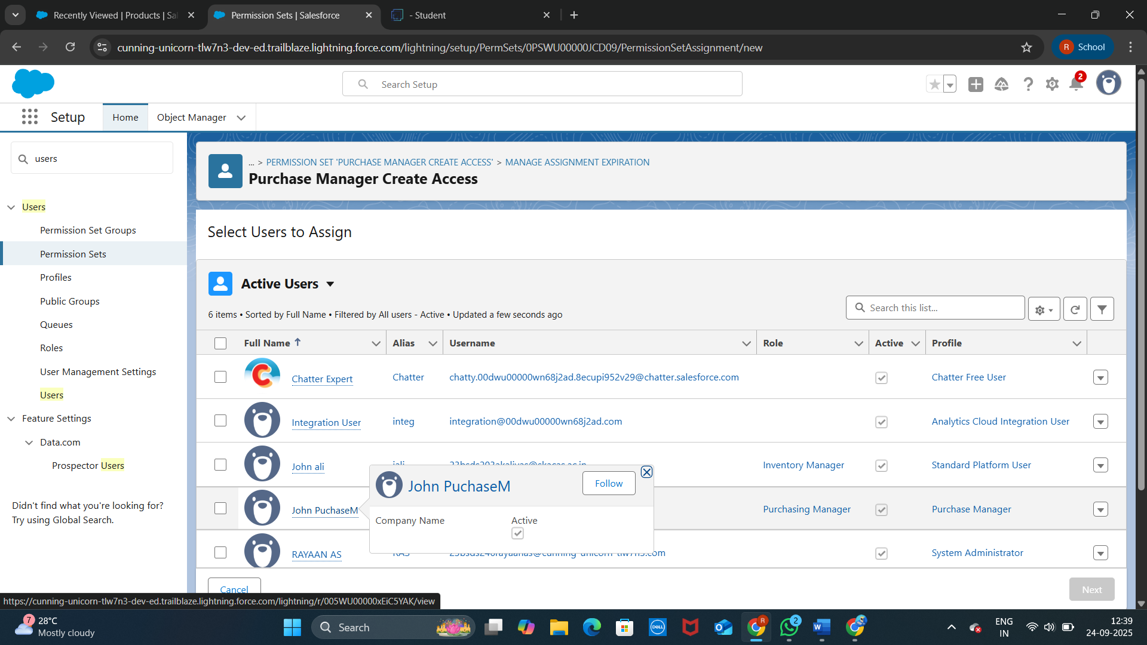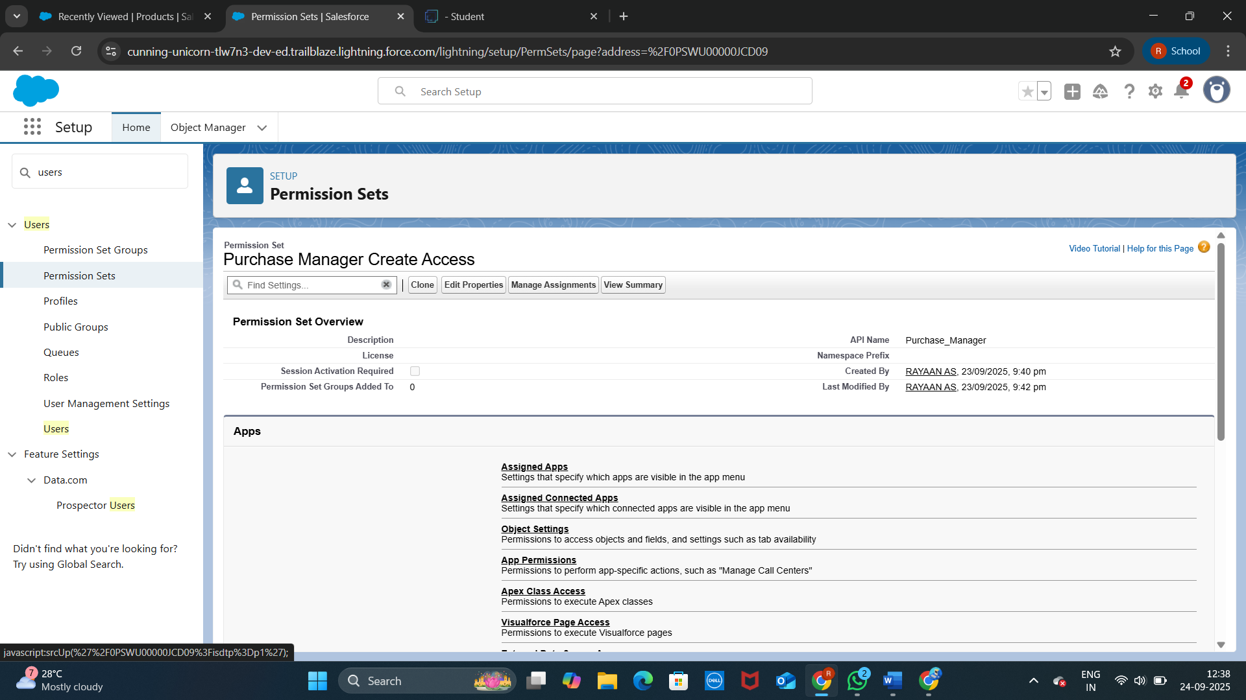

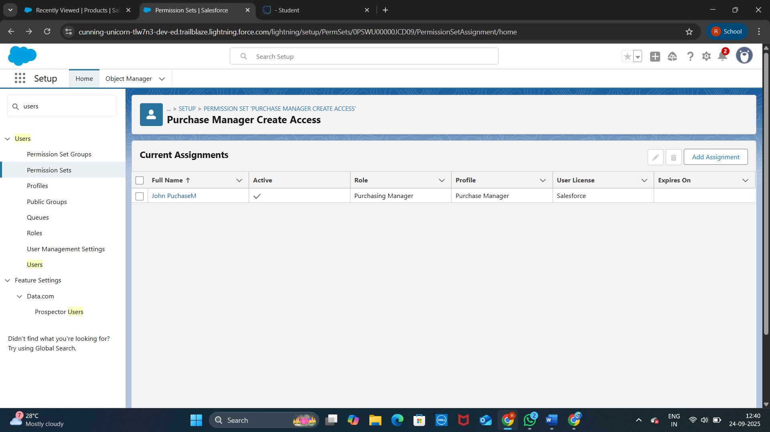

Flows

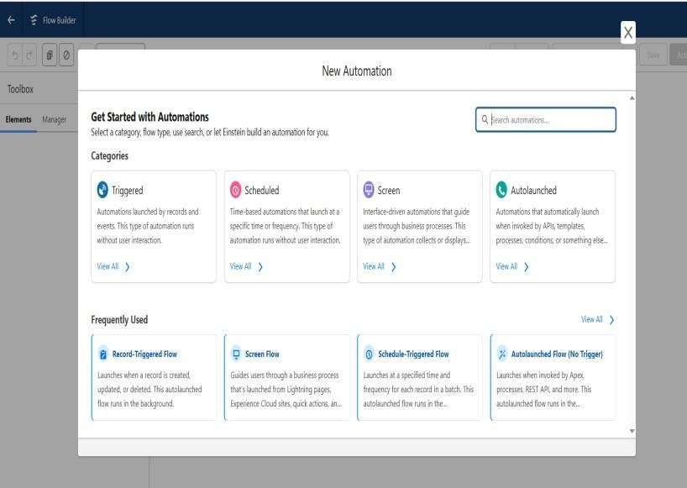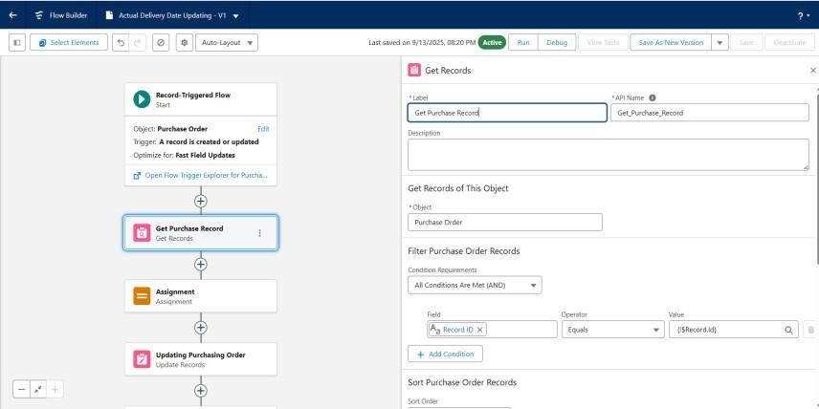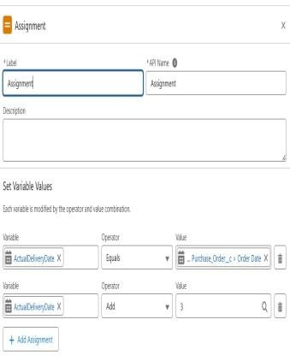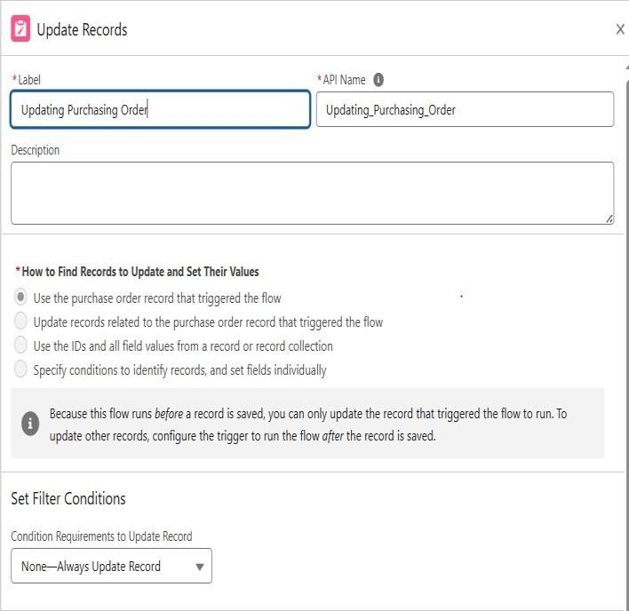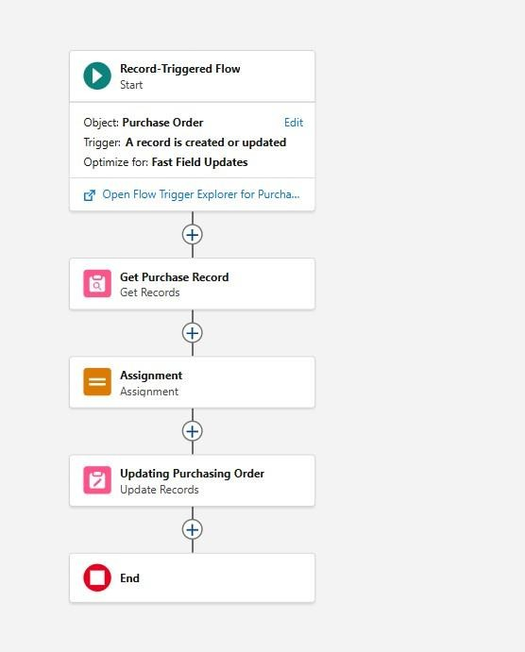

# Triggers

Trigger to calculate Total Order Cost from related Order Items and update Purchase Order.

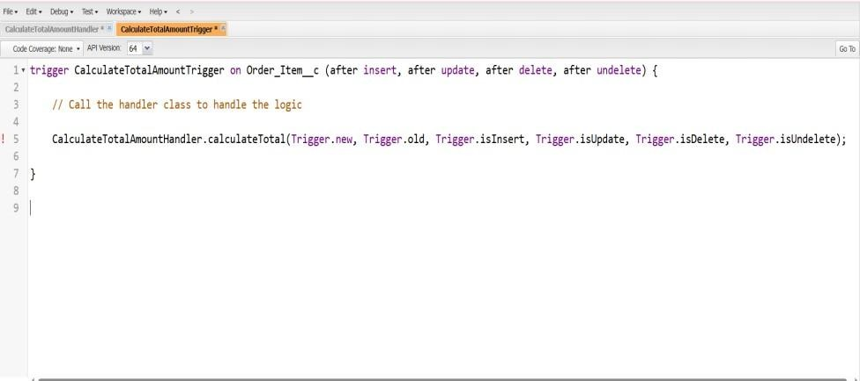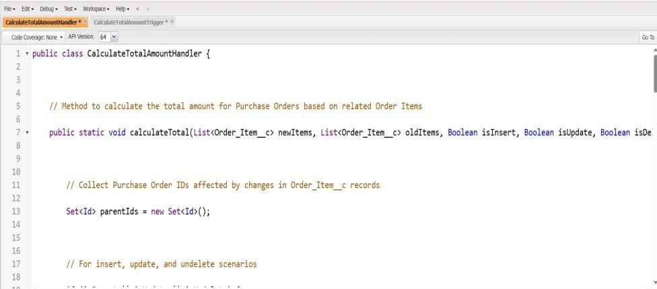

# Reports

Purchase Orders by Supplier Report – Group by Supplier ID, show Total Order Cost.

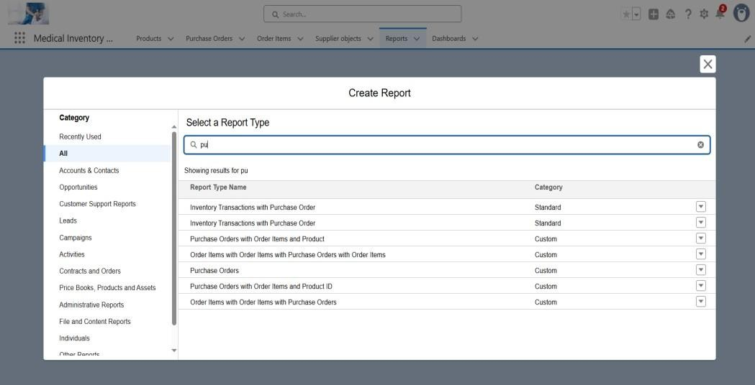

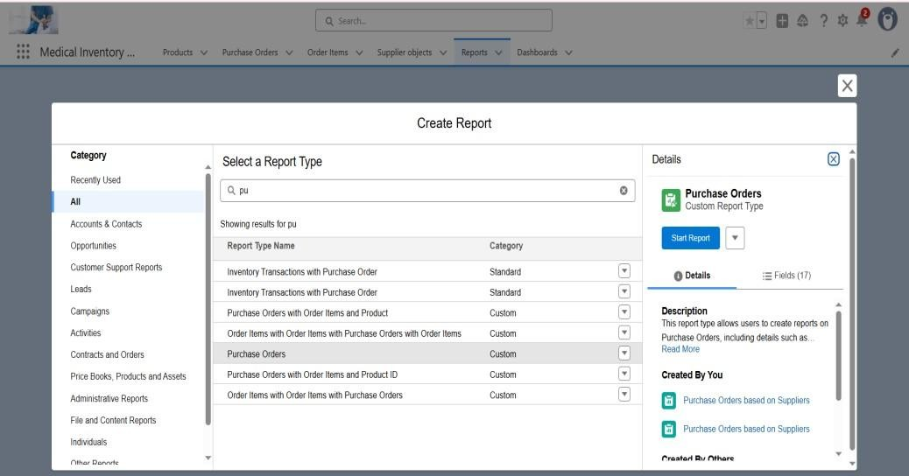

Complete Purchase Details Report – Show Supplier, Purchase Order, Products, Quantity, Amount.

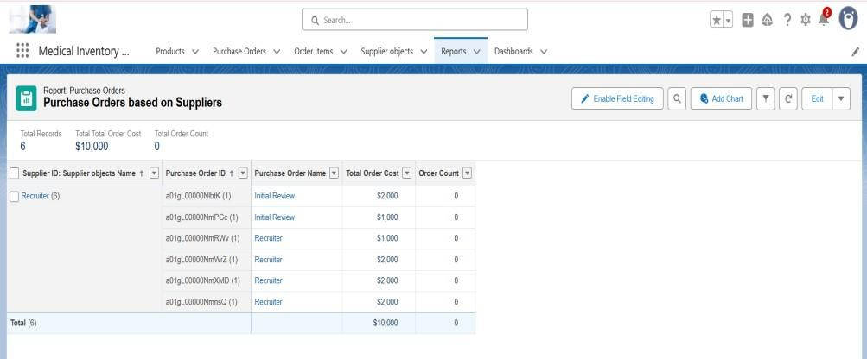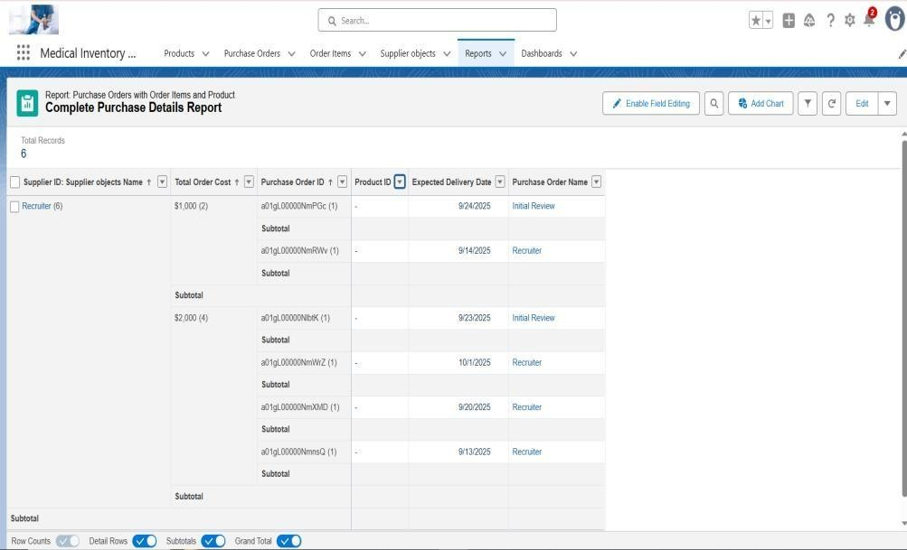

# Dashboards

Medical Inventory Dashboard

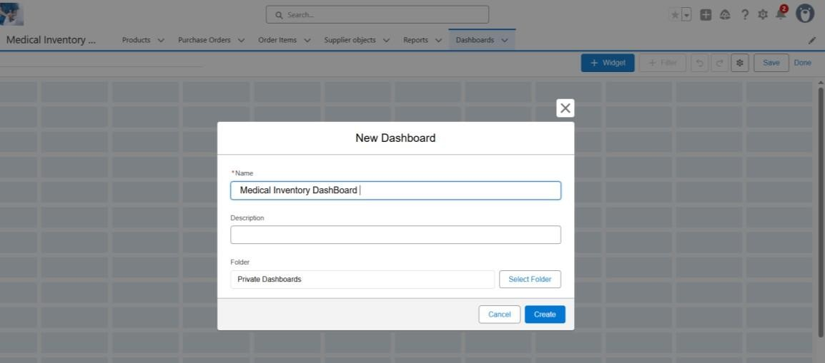

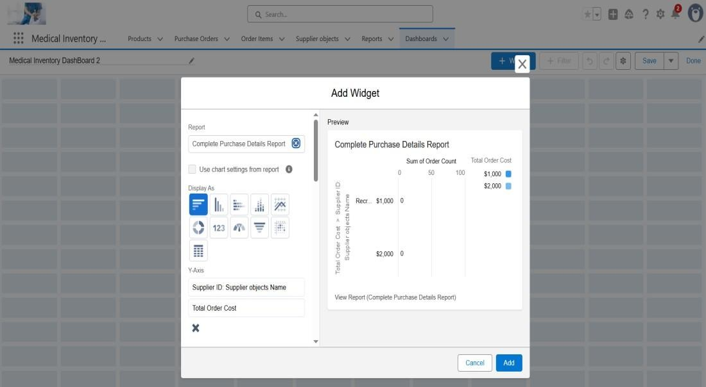

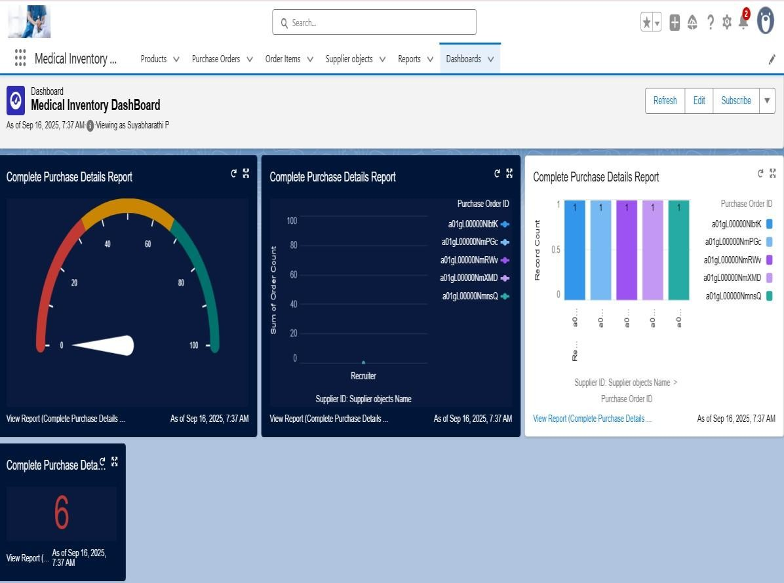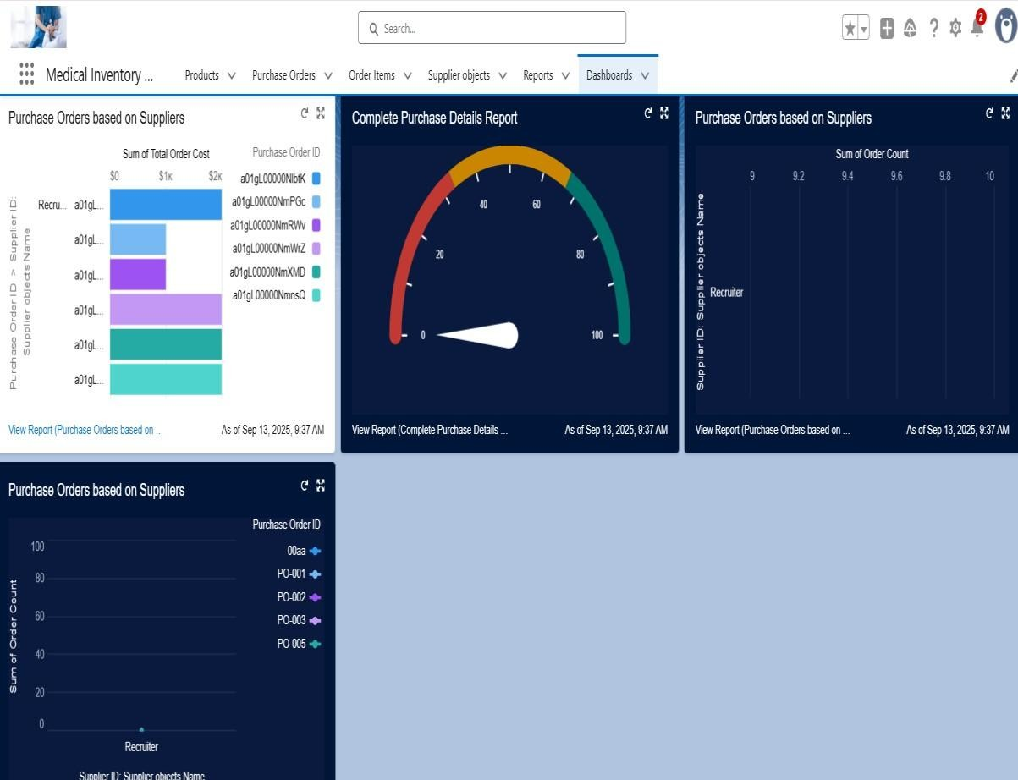

# Conclusion

The **Medical Inventory Management System** developed on Salesforce successfully demonstrates how CRM platforms can be leveraged to manage real-time inventory operations in the medical field. By creating **custom objects, fields, validation rules, flows, triggers, reports, and dashboards**, the project ensures accurate tracking of suppliers, products, purchase orders, and inventory transactions.

**Project Achievements:**

* Created a streamlined system for supplier and purchase order management.
* Automated order tracking and product stock updates using Flows and Triggers.
* Implemented strong security using Profiles, Roles, and Permission Sets.
* Generated real-time insights through Reports and Dashboards.

**Student Learning Outcomes:**

* Hands-on Salesforce CRM skills in a real-time use case.
* Ability to design custom objects, automation, and security models.
* Improved teamwork and collaboration in managing project lifecycle.
* Exposure to industry practices in CRM and inventory management.

**Future Scope:**

* Integration with barcode scanners for product entry.
* Mobile App support for order approvals and supplier management.
* Advanced AI-driven demand forecasting and stock optimization.
* Multi-branch scalability for large healthcare organizations.